CSA1203 ASSESSMENT

NAME: DHEVAGOPALAN B
REG NO: 192512134

Design and Analysis of an Energy-Efficient Pipelined Processor with Hierarchical Memory System for Smart Industrial Monitoring

System Architecture / Design
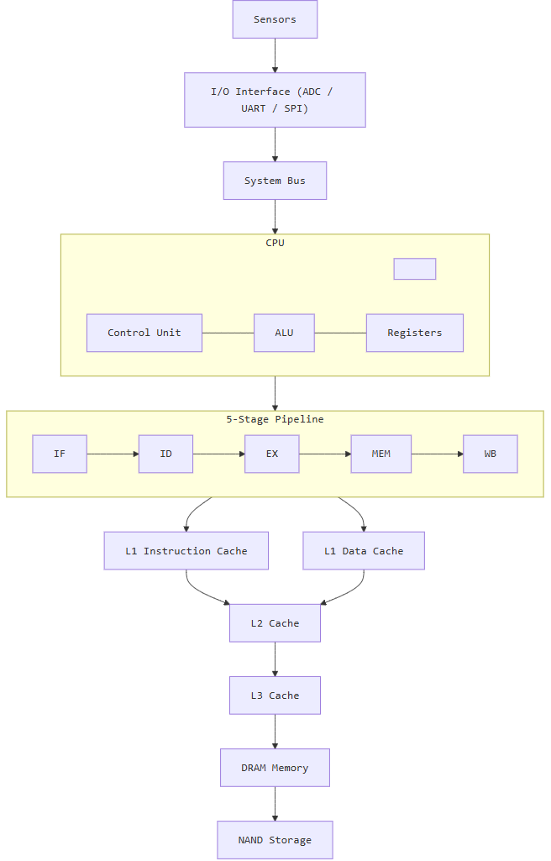

Calculations of
- CPI
- Clock cycles
- Execution time
- Speedup
- Cache hit/miss rate
- AMAT

1. CPI (Cycles Per Instruction)
Formula
$$CPI=\frac{Total Clock Cycles}{Total Instructions Executed}$$
Assume the optimized processor executes 1,000,000 instructions in 1,200,000 clock cycles.
$$CPI=\frac{1,200,000}{1,000,000} \\ \boxed{CPI=1.2}$$
Comparison
Processor Design | CPI
Non-Pipelined Processor | 4.5
Basic Pipelined Processor | 1.8
Optimized Pipelined Processor | 1.2
Result
The optimized pipelined processor has the lowest CPI of 1.2, indicating better instruction throughput.

2. Clock Cycle Time
Formula
$$Clock Cycle Time=\frac{1}{Clock Frequency}$$
Given:
$$Clock Frequency=1GHz \\ Clock Cycle Time=\frac{1}{1×{10}^{9}} \\ \boxed{Clock Cycle Time=1ns}$$
Result
Each processor clock cycle takes 1 nanosecond.

3. Total Clock Cycles
Formula
$$Total Clock Cycles=Instruction Count×CPI$$
Non-Pipelined Processor
$$=1,000,000×4.5 \\ \boxed{4,500,000 cycles}$$
Basic Pipeline
$$=1,000,000×1.8 \\ \boxed{1,800,000 cycles}$$
Optimized Pipeline
$$=1,000,000×1.2 \\ \boxed{1,200,000 cycles}$$
Comparison
Architecture | Instruction Count | CPI | Total Clock Cycles
Non-Pipelined | 1,000,000 | 4.5 | 4,500,000
Basic Pipeline | 1,000,000 | 1.8 | 1,800,000
Optimized Pipeline | 1,000,000 | 1.2 | 1,200,000

4. CPU Execution Time
Formula
$$CPU Execution Time=Total Clock Cycles×Clock Cycle Time$$
Alternatively:
$$CPU Execution Time=Instruction Count×CPI×Clock Cycle Time$$
A. Non-Pipelined Processor
$$=1,000,000×4.5×1ns \\ =4,500,000ns \\ \boxed{4.5ms}$$

B. Basic Pipelined Processor
$$=1,000,000×1.8×1ns \\ \boxed{1.8ms}$$

C. Optimized Pipelined Processor
$$=1,000,000×1.2×1ns \\ \boxed{1.2ms}$$
Final Comparison
Processor | Execution Time
Non-Pipelined | 4.5 ms
Basic Pipeline | 1.8 ms
Optimized Pipeline | 1.2 ms
Result
The optimized pipelined processor completes the same workload in the shortest time.

5. Speedup Calculation
Formula
$$Speedup=\frac{Execution Time of Old System}{Execution Time of New System}$$
Comparing non-pipelined and optimized pipelined processors:
$$Speedup=\frac{4.5}{1.2} \\ \boxed{Speedup=3.75}$$
Result
$$\boxed{The optimized pipeline is 3.75× faster}$$
than the non-pipelined processor.

6. Cache Hit Rate and Miss Rate
Given:
- Total Memory Accesses = 10,000
- Cache Hits = 9,500
- Cache Misses = 500
Cache Hit Rate
Formula
$$Hit Rate=\frac{Cache Hits}{Total Memory Accesses}×100 \\ =\frac{9500}{10000}×100 \\ \boxed{Hit Rate=95\%}$$

Cache Miss Rate
Formula
$$Miss Rate=\frac{Cache Misses}{Total Memory Accesses}×100 \\ =\frac{500}{10000}×100 \\ \boxed{Miss Rate=5\%}$$

Result
Parameter | Value
Total Accesses | 10,000
Cache Hits | 9,500
Cache Misses | 500
Hit Rate | 95%
Miss Rate | 5%
A high cache hit rate reduces expensive accesses to lower memory levels.

7. AMAT (Average Memory Access Time)
For a hierarchical memory system:
Formula
$$AMAT=L1 Hit Time+L1 Miss Rate×Miss Penalty$$
First calculate the L1 miss penalty.
L1 Miss Penalty
$$L1 Miss Penalty=L2 Access Time+L2 Miss Rate×Main Memory Access Time$$
Substitute:
$$=5+\left(0.10×100\right) \\ =5+10 \\ \boxed{L1 Miss Penalty=15ns}$$
Calculate AMAT
Given:
- L1 Hit Time = 1 ns
- L1 Miss Rate = 5% = 0.05
- L1 Miss Penalty = 15 ns
$$AMAT=1+\left(0.05×15\right) \\ =1+0.75$$

GRAPH COMPARISON

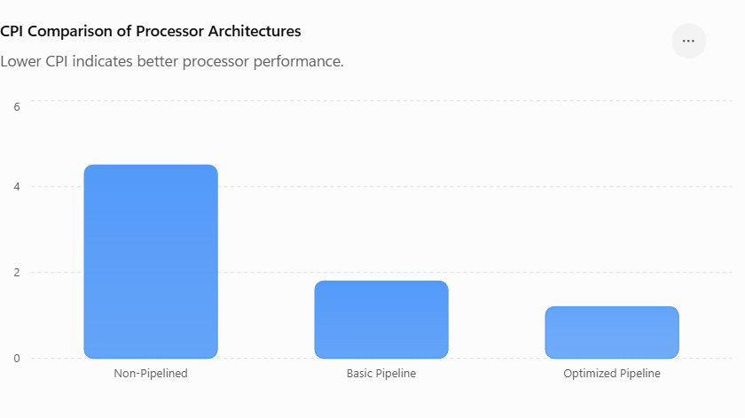
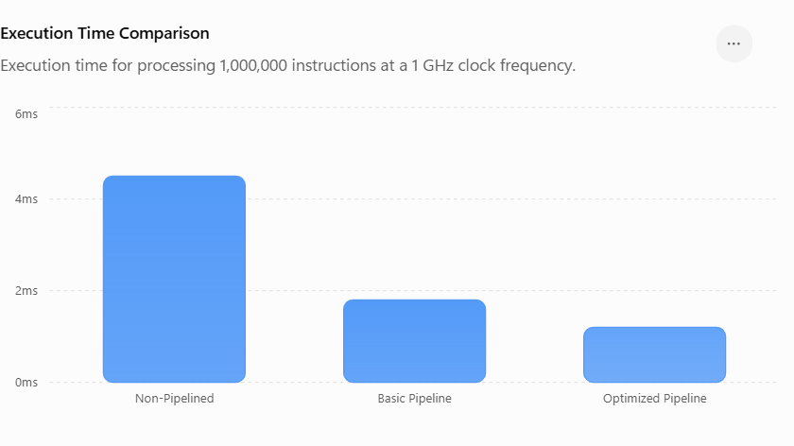

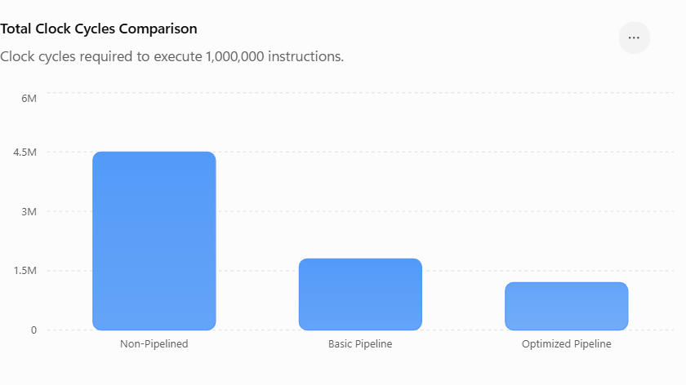
ROUGH GRAPH

CPI Comparison
CPI
4.5 ████████████████████ Non-Pipeline
1.8 ████████ Basic Pipeline
1.2 █████ Forwarding Pipeline

Graph 2: Execution Time Comparison
4.5ms ████████████████████ Non-Pipeline
1.8ms ████████ Basic Pipeline
1.2ms █████ Optimized Pipeline

Performance Comparison & Engineering Recommendation

Different processor organizations are compared based on performance, power consumption, and hardware complexity.
Pipelining with forwarding and hazard detection provides improved throughput with moderate complexity.
Complex out-of-order and speculative techniques are avoided where their additional power is not justified.
The proposed cache hierarchy reduces memory access latency and improves overall system performance.
Therefore, the optimized pipelined architecture is recommended for energy-efficient industrial monitoring.
SIMULATION

